15. Keep rows with at least 2 NaN values
import pandas as pd
import numpy as np

# Create DataFrame
df = pd.DataFrame({
'A': [10, np.nan, 30, np.nan, 50],
'B': [20, np.nan, np.nan, 40, 60],
'C': [30, 40, np.nan, np.nan, 70],
'D': [40, 50, 60, 70, np.nan]
})

print("Original DataFrame:")
print(df)

# Keep rows having at least 2 NaN values
result = df[df.isnull().sum(axis=1) >= 2]

print("\nRows with at least 2 NaN values:")
print(result)
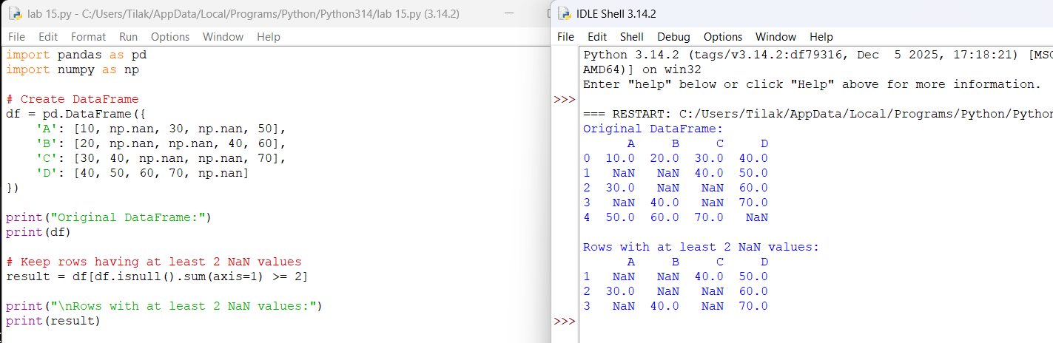

16. Split DataFrame into groups based on School Code
import pandas as pd

# Create DataFrame
data = {
'school_code': ['S001', 'S002', 'S001', 'S003',
'S002', 'S001', 'S003', 'S002'],

'name': ['Arun', 'Priya', 'Rahul', 'Anjali',
'Kiran', 'Ravi', 'Neha', 'Amit'],

'age': [18, 19, 17, 18, 20, 19, 21, 18]
}

df = pd.DataFrame(data)

print("Original DataFrame:")
print(df)

# Group by school code
grouped = df.groupby('school_code')

# Display groups
for code, group in grouped:
print("\nSchool Code:", code)
print(group)

# Check type
print("\nType of GroupBy object:")
print(type(grouped))
Output:
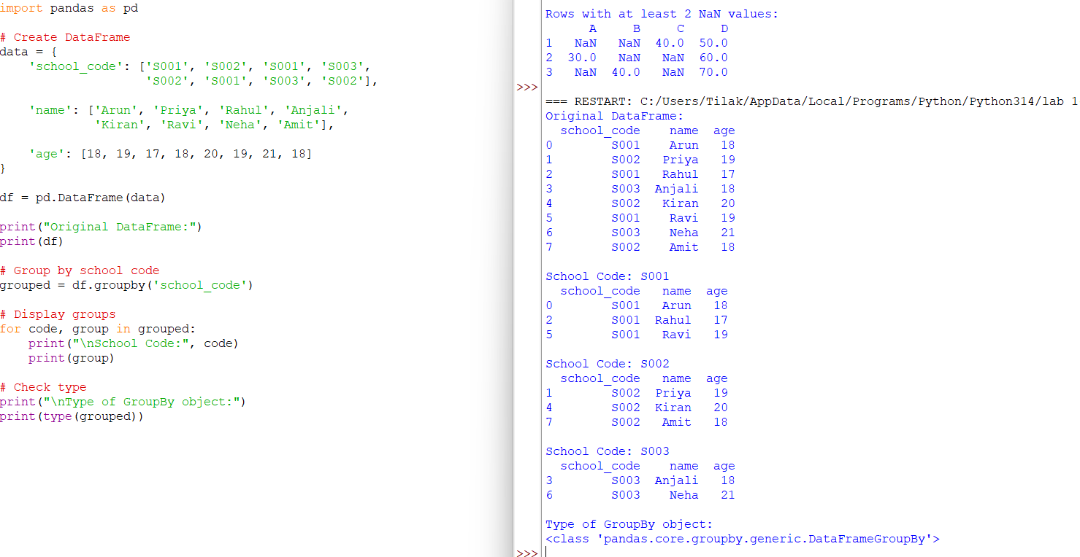
17. School Code-wise Mean, Minimum and Maximum Age
You can use the same school dataset.
import pandas as pd

data = {
'school_code': ['S001', 'S002', 'S001', 'S003',
'S002', 'S001', 'S003', 'S002'],

'name': ['Arun', 'Priya', 'Rahul', 'Anjali',
'Kiran', 'Ravi', 'Neha', 'Amit'],

'age': [18, 19, 17, 18, 20, 19, 21, 18]
}

df = pd.DataFrame(data)

print("Original DataFrame:")
print(df)

# Group by school code and calculate age statistics
result = df.groupby('school_code')['age'].agg(
['mean', 'min', 'max']
)

print("\nMean, Minimum and Maximum Age:")
print(result)
output:
